Luminaire Type | Luminaire Image | Description and Catalogue Number
Pathway Luminaires

A | 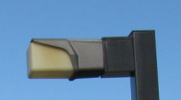 | 70W HPS?
B | 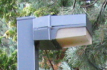 | 70W HPS?
C | 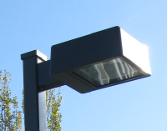 | 100W HPS?
C1 | Gardco BRM822 Bollard | 32W TRT
D | 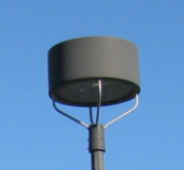 | 100W HPS?
F | 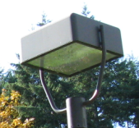 | 100W HPS?
G | 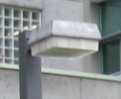 | 100W HPS?
G1 | PACE ASFL | 70W HPS
H | 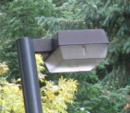 | 100W HPS?
Step Lights

J | 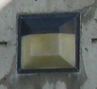 | 50W HPS?
K | 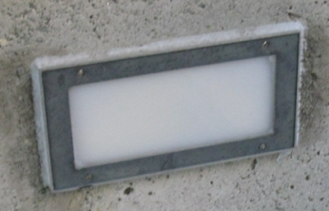 | 1-42W PLT?
K1 | PACE JRLS | 1-42W PLT
K2 | McPhilben 942 Series | 2-13W WTT
L | 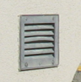 | 1-42W PLT?
M | 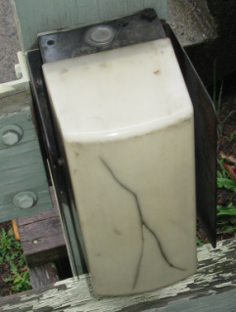 | 50W HPS?
N | 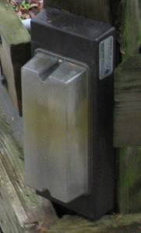 | 50W HPS?
Wall Mounted Building Lights

P | 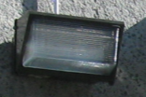 | 100W HPS?
Q | 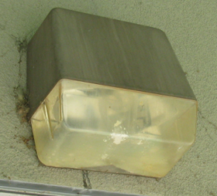 | 100W HPS?
Q1 | 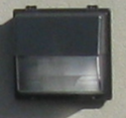 | 100W HPS
Q2 | McGraw Edson | 250W HPS
R | 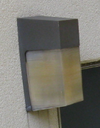 | 70 HPS?
S | 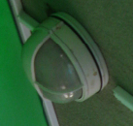 | 50W HPS?
T | 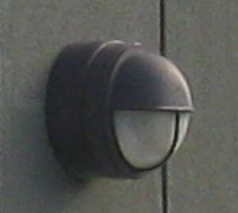 | 70W HPS
T1 | 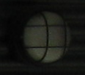 | 50W HPS
T2 | 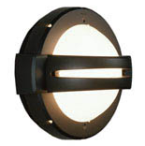Noral Othello | 50W MH
T4 | Quality DL Series | 1x22W PLC
U | 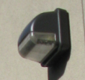 | 70W HPS
U1 | Unknown | 70W HPS
U2 | Unknown | 18W LPS
U3 | Unknown | 100W HPS
U4 | Holophane 410-120 | 100W MV
U5 | Holophane 400-120 | 200W MV
U6 | Electrolier | 150W
U7 | Holophane | 250W
U8 | Unknown | 2x26W CF
U9 | Unknown linear sign | 1x32W T8
U10 | Electroiler KACW | 2x40W T12
U11
V | 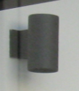 | 100W INC?
V1 | Pace TPWM | 2-32W PLT
W | 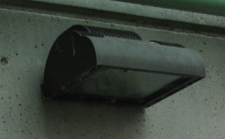 | 100W MH
W1 | PACE AEQS | 150W MH
X1 | 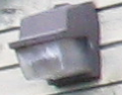 | 100W HPS?
X2 | Geometric Lighting Specialties GLS 36350 | 50W HPS
X3 | PRESCOLITE 4022 | 1OOW INC
X | 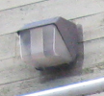 | 100W HPS?
Y | 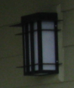 | ?
Z | 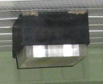 | 100W HPS?
AA | 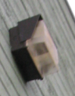 | 100W HPS?
BB | 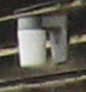 | 100W INC?
CC | 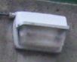 | 100W HPS?
DD1 | 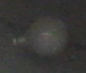 | 100W INC?
DD | 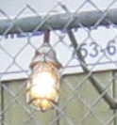 | 100W INC?
Ceiling Mounted Downlights

FF | 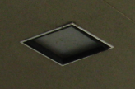 | 70W HPS
GG | 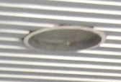 | 100W MH
HH | 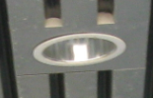 | 100W HPS?
JJ | 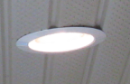 | 100W MH?
JJ1 | Lithonia LP8 | 70W HPS
JJ2 | Lithonia LP6 | 2-26W TRT
JJ3 | Lightolier LD73 | 70W MH
KK1 | Lithonia AF | 2x18W PL
KK | 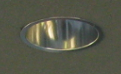 | 100W HPS?
Flood Lights

LL | 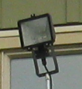 | 100HPS?
MM | 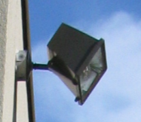 | 100HPS?
MM1 | 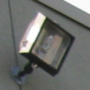 | 100HPS?
NN | 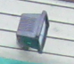 | 100HPS?
NN1 | BK Lighting K2 72 | 150W MH
PP | 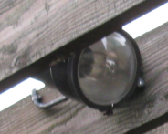 | 150W INC?
QQ | 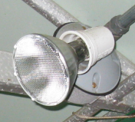 | 100W INC?
RR1 | RAB | 2-75W Par38
RR2 | RAB | 2-500W Par38
RR | 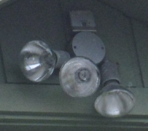 | 3-100W PAR38?
Parking Area Lights

SS1 | 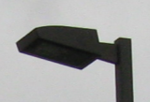 | 250W HPS PATHWAY/ROAD
SS |  | 400W HPS PARKING
TT | 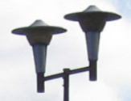 | 400W HPS?
UU | 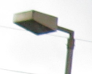 | 400W HPS?
VV | 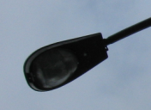 | 400W HPS?
XX | 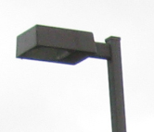  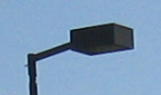 | 400W HPS?

